# **Measure Energy Consumption**

|  |  |
| --- | --- |
| Date | 09 October 2023 |
| Team ID | Proj_212174_Team_1 |
| Project Name | Measurement of Energy consumption |
| Maximum Marks |  |

#Importing the packages needed for the above given problem

import numpy as np

import pandas as pd

#importing the necessary packages and libraries for the above given problems

import numpy as np

from numpy import concatenate

import urllib.request as urllib

from sklearn.preprocessing import StandardScaler, MinMaxScaler, LabelEncoder, OneHotEncoder

from sklearn.model_selection import train_test_split

from sklearn.metrics import mean_squared_error

from keras.models import Sequential

from keras.layers import Dense

#importing seaborn and matplot libraries

import seaborn as sns

import matplotlib.pyplot as plt

from math import sqrt

#importing the required dataset libraries

from sklearn.metrics import mean_squared_error,mean_absolute_error

from keras.models import Sequential

from keras.layers import Dense,Dropout

from keras.layers import LSTM

color_pal = sns.color_palette()

#importing the dataset “PJME_hourly.csv “ file to create a table for the datetime of the dataset

data = pd.read_csv('PJME_hourly.csv',index_col=[0], parse_dates=[0])

data.head();

OUTPUT:

|  | **PJME_MW** |
| --- | --- |
| **Datetime** |  |
| **2002-12-31 01:00:00** | 26498.0 |
| **2002-12-31 02:00:00** | 25147.0 |
| **2002-12-31 03:00:00** | 24574.0 |
| **2002-12-31 04:00:00** | 24393.0 |
| **2002-12-31 05:00:00** | 24860.0 |

#Ploting a graph for the data set file

import seaborn as sns

sns.set(rc={'figure.figsize':(11, 4)})

data['PJME_MW'].plot(linewidth=0.5);

OUTPUT:

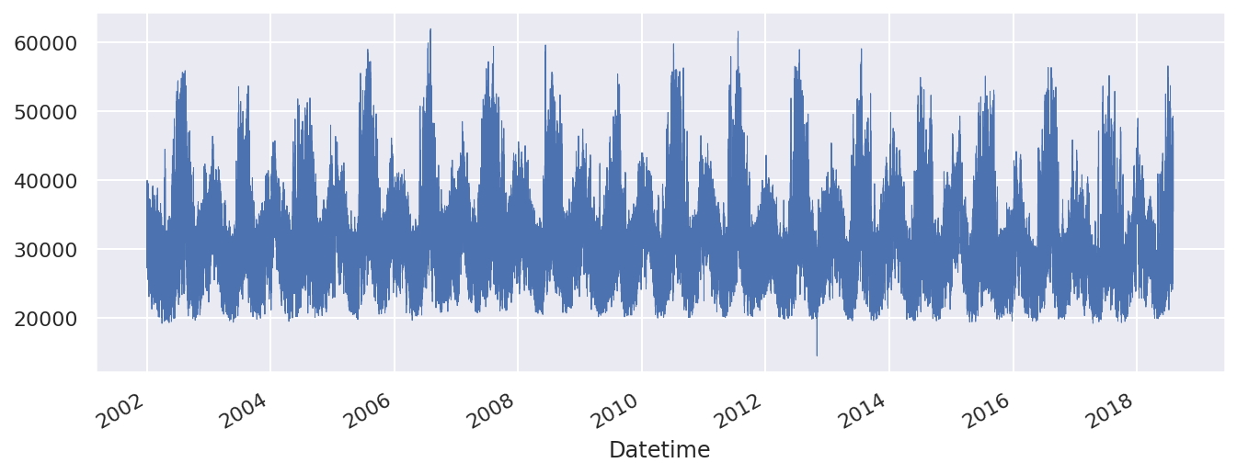

From the above graph we can analyse that datetime of the energy consumed from the years 2002 to 2018 from varies from each year throughout the energy consumed . We can also see that the between the years of 2006 and 2008 has the highest point of energy consumed.

#Finding if the dataset has any null values

data.isnull().sum()

OUTPUT:

PJME_MW 0

dtype: int64

#Ploting a graph to outline the outliers in the given dataset

data.query('PJME_MW < 19_000')['PJME_MW'] \

.plot(style='o',

figsize=(15, 5),

color=color_pal[5],

title='Outliers')

OUTPUT:

<Axes: title={'center': 'Outliers'}, xlabel='Datetime'>

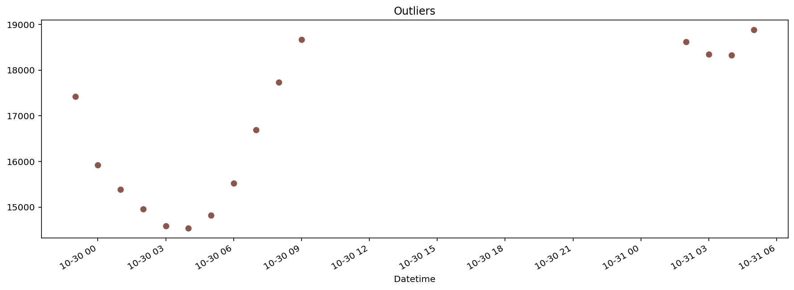

From the above graph we can see that there are outliers present in the dataset. There are four outliers present in the above graph.

#Datacleaning the dataset

import pandas as pd

data = pd.read_csv('PJME_hourly.csv',index_col=[0], parse_dates=[0])

data.head()

print("\nDataset after Data Cleaning:")

print(data.head())

OUTPUT:

Dataset after Data Cleaning: PJME_MW Datetime 2002-12-31 01:00:00 26498.0 2002-12-31 02:00:00 25147.0 2002-12-31 03:00:00 24574.0 2002-12-31 04:00:00 24393.0 2002-12-31 05:00:00 24860.0

#Plotting a table to differentiate between the years of calculations made from the dataset

def create_features(df, label=None):

"""

Creates time series features from datetime index.

"""

df = df.copy()

df['date'] = df.index

df['hour'] = df['date'].dt.hour

df['dayofweek'] = df['date'].dt.dayofweek

df['quarter'] = df['date'].dt.quarter

df['month'] = df['date'].dt.month

df['year'] = df['date'].dt.year

df['dayofyear'] = df['date'].dt.dayofyear

df['dayofmonth'] = df['date'].dt.day

df['weekofyear'] = df['date'].dt.weekofyear

X = df[['hour','dayofweek','quarter','month','year',

'dayofyear','dayofmonth','weekofyear']]

if label:

y = df[label]

return X, y

return X

X, y = create_features(data, label='PJME_MW')

df = pd.concat([X, y], axis=1) df.head()

OUTPUT:

|  | **hour** | **dayofweek** | **quarter** | **month** | **year** | **dayofyear** | **dayofmonth** | **weekofyear** | **PJME_MW** |
| --- | --- | --- | --- | --- | --- | --- | --- | --- | --- |
| **Datetime** |  |  |  |  |  |  |  |  |  |
| **2002-12-31 01:00:00** | 1 | 1 | 4 | 12 | 2002 | 365 | 31 | 1 | 26498.0 |
| **2002-12-31 02:00:00** | 2 | 1 | 4 | 12 | 2002 | 365 | 31 | 1 | 25147.0 |
| **2002-12-31 03:00:00** | 3 | 1 | 4 | 12 | 2002 | 365 | 31 | 1 | 24574.0 |
| **2002-12-31 04:00:00** | 4 | 1 | 4 | 12 | 2002 | 365 | 31 | 1 | 24393.0 |
| **2002-12-31 05:00:00** | 5 | 1 | 4 | 12 | 2002 | 365 | 31 | 1 | 24860.0 |

#Finding the mean for the dataset

mean = data.mean()

print("Mean:")

print(mean)

OUTPUT:

Mean:

PJME_MW 32080.222831

dtype: float64

#Finding the median for the dataset

median = data.median()

print("\nMedian:")

print(median)

OUTPUT:

Median:

PJME_MW 31421.0

dtype: float64

#Finding the mode for the dataset

mode = data.mode().iloc[0]

print("\nMode:")

print(mode)

OUTPUT:

Mode:

PJME_MW 30051.0

Name: 0, dtype: float64

The outliers and the null values in the dataset can be overcome by the mean, median, mode models which analyse the dataset for the null values and outliers present inside the data. These in terms help the dataset to remove unnecessary data values present in it . It may lead to removing of false values present in the dataset.

# Load the dataset

dataset_path = "path/to/hourly_energy_consumption.csv"

data = pd.read_csv(dataset_path)

# Explore the first few rows of the dataset

print("Initial Dataset:")

print(data.head())

# Data Cleaning: Handling missing values (if any)

data = data.dropna()

# Data Cleaning: Handling duplicate entries (if any)

data = data.drop_duplicates()

# Data Cleaning: Handling other errors (specific to your dataset)

055555555555555553

-+88888888+8/2# After cleaning

print("\nDataset 9aft.0-9er Data Cleaning:")

print(data.head())

# Further data preprocessing steps can be added based on project requirements

In the above code, replace "path/to/hourly_energy_consumption.csv" with the actual path where you have saved the downloaded dataset. This code snippet loads the dataset, removes any rows with missing values, and drops duplicate entries. You can add more specific cleaning operations based on the characteristics of your dataset, such as handling outliers, correcting inconsistent values, or dealing with formatting errors.

# Preprocess data

labelEncoder = LabelEncoder()

oneHotEncoder = OneHotEncoder(categorical_features=[0])

ss = StandardScaler()

values = df.values

# integer encode direction

#encoder = LabelEncoder()

#values[:,8] = encoder.fit_transform(values[:,8])

# ensure all data is float

values = values.astype('float32')

# normalize features

scaler = MinMaxScaler(feature_range=(0, 1))

scaled = scaler.fit_transform(values)

# frame as supervised learning

reframed = series_to_supervised(scaled, 1, 1)

# drop columns we don't want to predict

reframed.drop(reframed.columns[[9,10,11,12,13,14,15,16]], axis=1, inplace=True)

print(reframed.shape)

print(reframed.head())

OUTPUT:

(145366, 10)

var1(t-1) var2(t-1) var3(t-1) var4(t-1) var5(t-1) var6(t-1) \

0 NaN NaN NaN NaN NaN NaN

1 0.043478 0.166667 1.0 1.0 0.0 0.99726

2 0.086957 0.166667 1.0 1.0 0.0 0.99726

3 0.130435 0.166667 1.0 1.0 0.0 0.99726

4 0.173913 0.166667 1.0 1.0 0.0 0.99726

var7(t-1) var8(t-1) var9(t-1) var9(t)

0 NaN NaN NaN 0.251849

1 1.0 0.0 0.251849 0.223386

2 1.0 0.0 0.223386 0.211314

3 1.0 0.0 0.211314 0.207500

4 1.0 0.0 0.207500 0.217339

# make a prediction

yhat = model.predict(X_test)

X_test = X_test.reshape((X_test.shape[0], X_test.shape[2]))

# invert scaling for forecast

inv_yhat = concatenate((X_test[:,:-1],yhat), axis=1)

inv_yhat = scaler.inverse_transform(inv_yhat)

inv_yhat = inv_yhat[:,-1]

# invert scaling for actual

y_test = y_test.reshape((len(y_test), 1))

inv_y = concatenate((X_test[:,:-1],y_test), axis=1)

inv_y = scaler.inverse_transform(inv_y)

inv_y = inv_y[:,-1]

# calculate RMSE

MSE=mean_squared_error(inv_y,inv_yhat)

MAE=mean_absolute_error(inv_y,inv_yhat)

RMSE = sqrt(mean_squared_error(inv_y, inv_yhat))

print('MSE: %.3f' % MSE + ' MAE: %.3f' % MAE + ' RMSE: %.3f' % RMSE)

OUTPUT:

MSE: 1522100.750 MAE: 933.959 RMSE: 1233.734

#Calculates the MAPE for the dataset

def mean_absolute_percentage_error(y_true, y_pred):

"""Calculates MAPE given y_true and y_pred"""

y_true, y_pred = np.array(y_true), np.array(y_pred)

return np.mean(np.abs((y_true - y_pred) / y_true)) * 100

print(mean_absolute_percentage_error(inv_y,inv_yhat))

OUTPUT:

3.113434463739395

#Plotting a graph to differentiate the actual value and the predicted value from the datasets file and plots the difference

aa=[x for x in range(500)]

plt.figure(figsize=(8,4))

plt.plot(aa, inv_y[:500], marker='.', label="actual")

plt.plot(aa, inv_yhat[:500], 'r', label="prediction")

plt.tight_layout()

sns.despine(top=True)

plt.subplots_adjust(left=0.07)

plt.ylabel('PJME_MW', size=15)

plt.xlabel('Time step', size=15)

plt.legend(fontsize=15)

plt.show();

OUTPUT: 